# Tutorial: Create a web API with ASP.NET Core

https://docs.microsoft.com/en-us/aspnet/core/tutorials/first-web-api?view=aspnetcore-5.0&tabs=visual-studio

In this tutorial, you learn how to:

* Create a web API project.
* Add a model class and a database context.
* Scaffold a controller with CRUD methods.
* Configure routing, URL paths, and return values.
* Call the web API with Postman.

## Overview

This tutorial creates the following API:

| **OVERVIEW** | | | |
| --- | --- | --- | --- |
| **API** | **Description** | **Request body** | **Response body** |
| GET /api/todoitems | Get all to-do items | None | Array of to-do items |
| GET /api/todoitems/{id} | Get an item by ID | None | To-do item |
| POST /api/todoitems | Add a new item | To-do item | To-do item |
| PUT /api/todoitems/{id} | Update an existing item | To-do item | None |
| DELETE /api/todoitems/{id} | Delete an item | None | None |

The following diagram shows the design of the app.

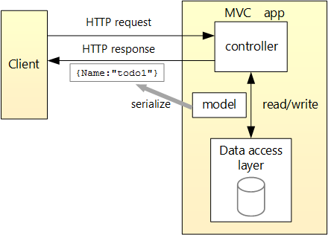

## Create a web project

* From the **File** menu, select **New** > **Project**.
* Select the **ASP.NET Core Web API** template and click **Next**.
* Name the project TodoApi and click **Create**.
* In the **Create a new ASP.NET Core Web Application** dialog, confirm that **.NET Core** and **ASP.NET Core 5.0** are selected. Select the **API** template and click **Create**.

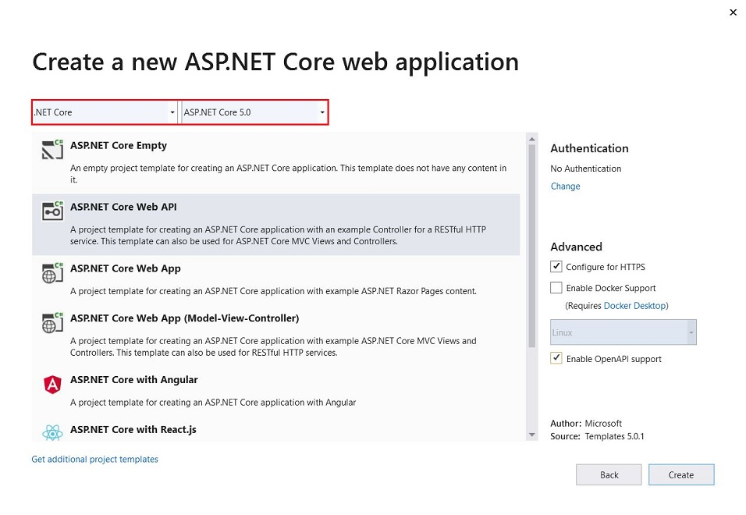

### Test the project

The project template creates a WeatherForecast API with support for [Swagger](https://docs.microsoft.com/en-us/aspnet/core/tutorials/web-api-help-pages-using-swagger?view=aspnetcore-5.0).

Press Ctrl+F5 to run without the debugger.

Visual Studio displays the following dialog when a project is not yet configured to use SSL:

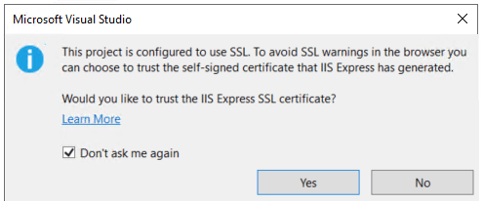

Select **Yes** if you trust the IIS Express SSL certificate.

The following dialog is displayed:

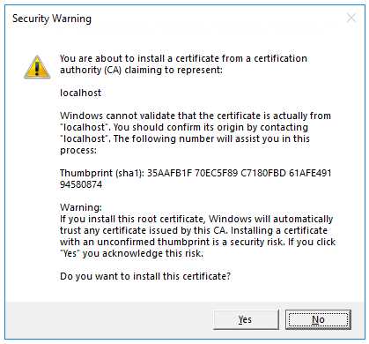

Select **Yes** if you agree to trust the development certificate.

For information on trusting the Firefox browser, see [Firefox SEC_ERROR_INADEQUATE_KEY_USAGE certificate error](https://docs.microsoft.com/en-us/aspnet/core/security/enforcing-ssl?view=aspnetcore-5.0#trust-ff).

Visual Studio launches:

* The IIS Express web server.
* The default browser and navigates to https://localhost:<port>/swagger/index.html, where <port> is a randomly chosen port number.

The Swagger page /swagger/index.html is displayed. Select **GET** > **Try it out** > **Execute**. The page displays:

* The [Curl](https://curl.haxx.se/) command to test the WeatherForecast API.
* The URL to test the WeatherForecast API.
* The response code, body, and headers.
* A drop down list box with media types and the example value and schema.

If the Swagger page doesn't appear, see [this GitHub issue](https://github.com/dotnet/AspNetCore.Docs/issues/21647).

Swagger is used to generate useful documentation and help pages for web APIs. This tutorial focuses on creating a web API. For more information on Swagger, see [ASP.NET Core web API documentation with Swagger / OpenAPI](https://docs.microsoft.com/en-us/aspnet/core/tutorials/web-api-help-pages-using-swagger?view=aspnetcore-5.0).

Copy and paste the **Request URL** in the browser: https://localhost:<port>/WeatherForecast

JSON similar to the following is returned:

JSONCopy

[

{

"date": "2019-07-16T19:04:05.7257911-06:00",

"temperatureC": 52,

"temperatureF": 125,

"summary": "Mild"

},

{

"date": "2019-07-17T19:04:05.7258461-06:00",

"temperatureC": 36,

"temperatureF": 96,

"summary": "Warm"

},

{

"date": "2019-07-18T19:04:05.7258467-06:00",

"temperatureC": 39,

"temperatureF": 102,

"summary": "Cool"

},

{

"date": "2019-07-19T19:04:05.7258471-06:00",

"temperatureC": 10,

"temperatureF": 49,

"summary": "Bracing"

},

{

"date": "2019-07-20T19:04:05.7258474-06:00",

"temperatureC": -1,

"temperatureF": 31,

"summary": "Chilly"

}

]

### Update the launchUrl

In Properties\launchSettings.json, update launchUrl from "swagger" to "api/todoitems":

JSONCopy

"launchUrl": "api/todoitems",

Because Swagger will be removed, the preceding markup changes the URL that is launched to the GET method of the controller added in the following sections.

## Add a model class

A model is a set of classes that represent the data that the app manages. The model for this app is a single TodoItem class.

* In **Solution Explorer**, right-click the project. Select **Add** > **New Folder**. Name the folder Models.
* Right-click the Models folder and select **Add** > **Class**. Name the class TodoItem and select **Add**.
* Replace the template code with the following:

namespace TodoApi.Models

{

public class TodoItem

{

public long Id { get; set; }

public string Name { get; set; }

public bool IsComplete { get; set; }

}

}

The Id property functions as the unique key in a relational database.

Model classes can go anywhere in the project, but the Models folder is used by convention.

## Add a database context

The database context is the main class that coordinates Entity Framework functionality for a data model. This class is created by deriving from the [Microsoft.EntityFrameworkCore.DbContext](https://docs.microsoft.com/en-us/dotnet/api/microsoft.entityframeworkcore.dbcontext) class.

### Add NuGet packages

* From the **Tools** menu, select **NuGet Package Manager > Manage NuGet Packages for Solution**.
* Select the **Browse** tab, and then enter Microsoft.EntityFrameworkCore.InMemory in the search box.
* Select Microsoft.EntityFrameworkCore.InMemory in the left pane.
* Select the **Project** checkbox in the right pane and then select **Install**.

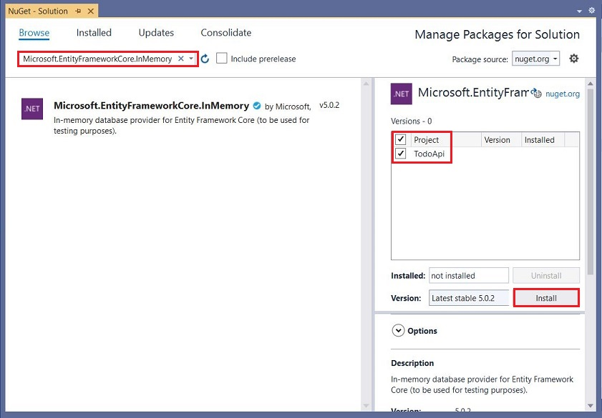

## Add the TodoContext database context

* Right-click the Models folder and select **Add** > **Class**. Name the class TodoContext and click **Add**.

using Microsoft.EntityFrameworkCore;

namespace TodoApi.Models

{

public class TodoContext : DbContext

{

public TodoContext(DbContextOptions<TodoContext> options)

: base(options)

{

}

public DbSet<TodoItem> TodoItems { get; set; }

}

}

## Register the database context

In ASP.NET Core, services such as the DB context must be registered with the [dependency injection (DI)](https://docs.microsoft.com/en-us/aspnet/core/fundamentals/dependency-injection?view=aspnetcore-5.0) container. The container provides the service to controllers.

Update Startup.cs with the following code:

// Unused usings removed

using Microsoft.AspNetCore.Builder;

using Microsoft.AspNetCore.Hosting;

using Microsoft.Extensions.Configuration;

using Microsoft.Extensions.DependencyInjection;

using Microsoft.Extensions.Hosting;

using Microsoft.EntityFrameworkCore;

using TodoApi.Models;

namespace TodoApi

{

public class Startup

{

public Startup(IConfiguration configuration)

{

Configuration = configuration;

}

public IConfiguration Configuration { get; }

public void ConfigureServices(IServiceCollection services)

{

services.AddControllers();

services.AddDbContext<TodoContext>(opt =>

opt.UseInMemoryDatabase("TodoList"));

//services.AddSwaggerGen(c =>

//{

// c.SwaggerDoc("v1", new OpenApiInfo { Title = "TodoApi", Version = "v1" });

//});

}

public void Configure(IApplicationBuilder app, IWebHostEnvironment env)

{

if (env.IsDevelopment())

{

app.UseDeveloperExceptionPage();

//app.UseSwagger();

//app.UseSwaggerUI(c => c.SwaggerEndpoint("/swagger/v1/swagger.json", "TodoApi v1"));

}

app.UseHttpsRedirection();

app.UseRouting();

app.UseAuthorization();

app.UseEndpoints(endpoints =>

{

endpoints.MapControllers();

});

}

}

}

The preceding code:

* Removes the Swagger calls.
* Removes unused using declarations.
* Adds the database context to the DI container.
* Specifies that the database context will use an in-memory database.

## Scaffold a controller

* Right-click the Controllers folder.
* Select **Add** > **New Scaffolded Item**.
* Select **API Controller with actions, using Entity Framework**, and then select **Add**.
* In the **Add API Controller with actions, using Entity Framework** dialog:
  + Select **TodoItem (TodoApi.Models)** in the **Model class**.
  + Select **TodoContext (TodoApi.Models)** in the **Data context class**.
  + Select **Add**.

The generated code:

* Marks the class with the [[ApiController]](https://docs.microsoft.com/en-us/dotnet/api/microsoft.aspnetcore.mvc.apicontrollerattribute) attribute. This attribute indicates that the controller responds to web API requests. For information about specific behaviors that the attribute enables, see [Create web APIs with ASP.NET Core](https://docs.microsoft.com/en-us/aspnet/core/web-api/?view=aspnetcore-5.0).
* Uses DI to inject the database context (TodoContext) into the controller. The database context is used in each of the [CRUD](https://wikipedia.org/wiki/Create,_read,_update_and_delete) methods in the controller.

The ASP.NET Core templates for:

* Controllers with views include [action] in the route template.
* API controllers don't include [action] in the route template.

When the [action] token isn't in the route template, the [action](https://docs.microsoft.com/en-us/aspnet/core/mvc/controllers/routing?view=aspnetcore-5.0#action) name is excluded from the route. That is, the action's associated method name isn't used in the matching route.

## Update the PostTodoItem create method

Update the return statement in the PostTodoItem to use the [nameof](https://docs.microsoft.com/en-us/dotnet/csharp/language-reference/operators/nameof) operator:

// POST: api/TodoItems

[HttpPost]

public async Task<ActionResult<TodoItem>> PostTodoItem(TodoItem todoItem)

{

_context.TodoItems.Add(todoItem);

await _context.SaveChangesAsync();

//return CreatedAtAction("GetTodoItem", new { id = todoItem.Id }, todoItem);

return CreatedAtAction(nameof(GetTodoItem), new { id = todoItem.Id }, todoItem);

}

The preceding code is an HTTP POST method, as indicated by the [[HttpPost]](https://docs.microsoft.com/en-us/dotnet/api/microsoft.aspnetcore.mvc.httppostattribute) attribute. The method gets the value of the to-do item from the body of the HTTP request.

For more information, see [Attribute routing with Http[Verb] attributes](https://docs.microsoft.com/en-us/aspnet/core/mvc/controllers/routing?view=aspnetcore-5.0#verb).

The [CreatedAtAction](https://docs.microsoft.com/en-us/dotnet/api/microsoft.aspnetcore.mvc.controllerbase.createdataction) method:

* Returns an [HTTP 201 status code](https://developer.mozilla.org/docs/Web/HTTP/Status/201) if successful. HTTP 201 is the standard response for an HTTP POST method that creates a new resource on the server.
* Adds a [Location](https://developer.mozilla.org/docs/Web/HTTP/Headers/Location) header to the response. The Location header specifies the [URI](https://developer.mozilla.org/docs/Glossary/URI) of the newly created to-do item. For more information, see [10.2.2 201 Created](https://www.w3.org/Protocols/rfc2616/rfc2616-sec10.html).
* References the GetTodoItem action to create the Location header's URI. The C# nameof keyword is used to avoid hard-coding the action name in the CreatedAtAction call.

### Install Postman

This tutorial uses Postman to test the web API.

* Install [Postman](https://www.getpostman.com/downloads/)
* Start the web app.
* Start Postman.
* Disable **SSL certificate verification**
  + From **File** > **Settings** (**General** tab), disable **SSL certificate verification**.

**Warning**

Re-enable SSL certificate verification after testing the controller.

### Test PostTodoItem with Postman

* Create a new request.
* Set the HTTP method to POST.
* Set the URI to https://localhost:<port>/api/todoitems. For example, https://localhost:5001/api/todoitems.
* Select the **Body** tab.
* Select the **raw** radio button.
* Set the type to **JSON (application/json)**.
* In the request body enter JSON for a to-do item:

JSONCopy

{

"name":"walk dog",

"isComplete":true

}

* Select **Send**.

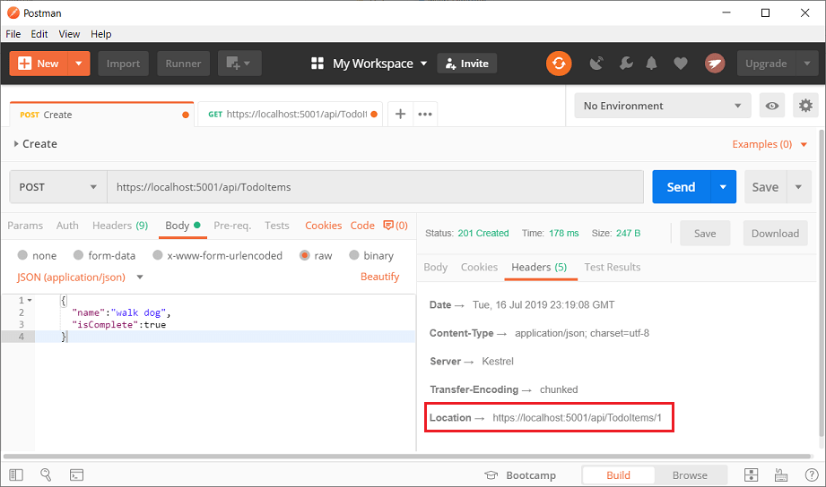

### Test the location header URI

The location header URI can be tested in the browser. Copy and paste the location header URI into the browser.

To test in Postman:

* Select the **Headers** tab in the **Response** pane.
* Copy the **Location** header value:



* Set the HTTP method to GET.
* Set the URI to https://localhost:<port>/api/todoitems/1. For example, https://localhost:5001/api/todoitems/1.
* Select **Send**.

## Examine the GET methods

Two GET endpoints are implemented:

* GET /api/todoitems
* GET /api/todoitems/{id}

Test the app by calling the two endpoints from a browser or Postman. For example:

* https://localhost:5001/api/todoitems
* https://localhost:5001/api/todoitems/1

A response similar to the following is produced by the call to GetTodoItems:

JSONCopy

[

{

"id": 1,

"name": "Item1",

"isComplete": false

}

]

### Test Get with Postman

* Create a new request.
* Set the HTTP method to **GET**.
* Set the request URI to https://localhost:<port>/api/todoitems. For example, https://localhost:5001/api/todoitems.
* Set **Two pane view** in Postman.
* Select **Send**.

This app uses an in-memory database. If the app is stopped and started, the preceding GET request will not return any data. If no data is returned, [POST](https://docs.microsoft.com/en-us/aspnet/core/tutorials/first-web-api?view=aspnetcore-5.0&tabs=visual-studio#post) data to the app.

## Routing and URL paths

The [[HttpGet]](https://docs.microsoft.com/en-us/dotnet/api/microsoft.aspnetcore.mvc.httpgetattribute) attribute denotes a method that responds to an HTTP GET request. The URL path for each method is constructed as follows:

* Start with the template string in the controller's Route attribute:

[Route("api/[controller]")]

[ApiController]

public class TodoItemsController : ControllerBase

{

private readonly TodoContext _context;

public TodoItemsController(TodoContext context)

{

_context = context;

}

* Replace [controller] with the name of the controller, which by convention is the controller class name minus the "Controller" suffix. For this sample, the controller class name is **TodoItems**Controller, so the controller name is "TodoItems". ASP.NET Core [routing](https://docs.microsoft.com/en-us/aspnet/core/mvc/controllers/routing?view=aspnetcore-5.0) is case insensitive.
* If the [HttpGet] attribute has a route template (for example, [HttpGet("products")]), append that to the path. This sample doesn't use a template. For more information, see [Attribute routing with Http[Verb] attributes](https://docs.microsoft.com/en-us/aspnet/core/mvc/controllers/routing?view=aspnetcore-5.0#verb).

In the following GetTodoItem method, "{id}" is a placeholder variable for the unique identifier of the to-do item. When GetTodoItem is invoked, the value of "{id}" in the URL is provided to the method in its id parameter.

// GET: api/TodoItems/5

[HttpGet("{id}")]

public async Task<ActionResult<TodoItem>> GetTodoItem(long id)

{

var todoItem = await _context.TodoItems.FindAsync(id);

if (todoItem == null)

{

return NotFound();

}

return todoItem;

}

## Return values

The return type of the GetTodoItems and GetTodoItem methods is [ActionResult<T> type](https://docs.microsoft.com/en-us/aspnet/core/web-api/action-return-types?view=aspnetcore-5.0" \l "actionresultt-type). ASP.NET Core automatically serializes the object to [JSON](https://www.json.org/) and writes the JSON into the body of the response message. The response code for this return type is [200 OK](https://developer.mozilla.org/docs/Web/HTTP/Status/200), assuming there are no unhandled exceptions. Unhandled exceptions are translated into 5xx errors.

ActionResult return types can represent a wide range of HTTP status codes. For example, GetTodoItem can return two different status values:

* If no item matches the requested ID, the method returns a [404 status](https://developer.mozilla.org/docs/Web/HTTP/Status/404) [NotFound](https://docs.microsoft.com/en-us/dotnet/api/microsoft.aspnetcore.mvc.controllerbase.notfound) error code.
* Otherwise, the method returns 200 with a JSON response body. Returning item results in an HTTP 200 response.

## The PutTodoItem method

Examine the PutTodoItem method:

// PUT: api/TodoItems/5

[HttpPut("{id}")]

public async Task<IActionResult> PutTodoItem(long id, TodoItem todoItem)

{

if (id != todoItem.Id)

{

return BadRequest();

}

_context.Entry(todoItem).State = EntityState.Modified;

try

{

await _context.SaveChangesAsync();

}

catch (DbUpdateConcurrencyException)

{

if (!TodoItemExists(id))

{

return NotFound();

}

else

{

throw;

}

}

return NoContent();

}

PutTodoItem is similar to PostTodoItem, except it uses HTTP PUT. The response is [204 (No Content)](https://www.w3.org/Protocols/rfc2616/rfc2616-sec9.html). According to the HTTP specification, a PUT request requires the client to send the entire updated entity, not just the changes. To support partial updates, use [HTTP PATCH](https://docs.microsoft.com/en-us/dotnet/api/microsoft.aspnetcore.mvc.httppatchattribute).

If you get an error calling PutTodoItem, call GET to ensure there's an item in the database.

### Test the PutTodoItem method

This sample uses an in-memory database that must be initialized each time the app is started. There must be an item in the database before you make a PUT call. Call GET to ensure there's an item in the database before making a PUT call.

Update the to-do item that has Id = 1 and set its name to "feed fish":

JSONCopy

{

"Id":1,

"name":"feed fish",

"isComplete":true

}

The following image shows the Postman update:

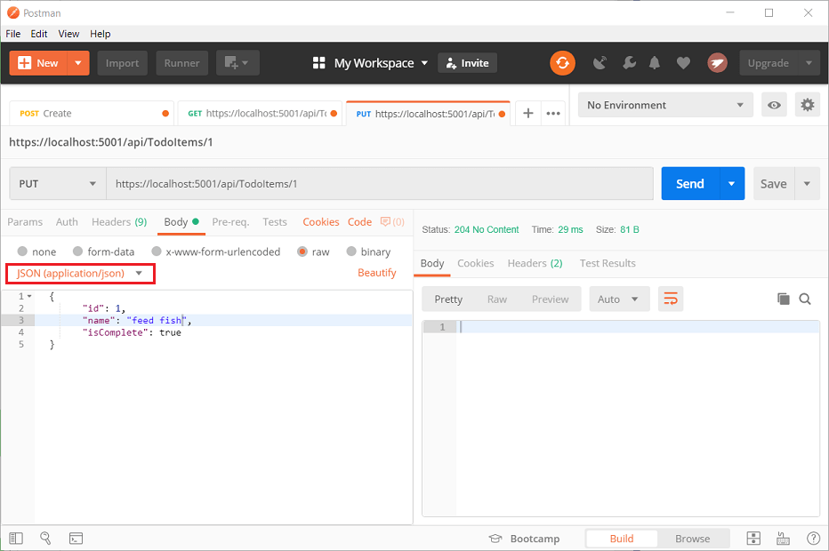

## The DeleteTodoItem method

Examine the DeleteTodoItem method:

// DELETE: api/TodoItems/5

[HttpDelete("{id}")]

public async Task<IActionResult> DeleteTodoItem(long id)

{

var todoItem = await _context.TodoItems.FindAsync(id);

if (todoItem == null)

{

return NotFound();

}

_context.TodoItems.Remove(todoItem);

await _context.SaveChangesAsync();

return NoContent();

}

### Test the DeleteTodoItem method

Use Postman to delete a to-do item:

* Set the method to DELETE.
* Set the URI of the object to delete (for example https://localhost:5001/api/todoitems/1).
* Select **Send**.

## Prevent over-posting

Currently the sample app exposes the entire TodoItem object. Production apps typically limit the data that's input and returned using a subset of the model. There are multiple reasons behind this and security is a major one. The subset of a model is usually referred to as a Data Transfer Object (DTO), input model, or view model. **DTO** is used in this article.

A DTO may be used to:

* Prevent over-posting.
* Hide properties that clients are not supposed to view.
* Omit some properties in order to reduce payload size.
* Flatten object graphs that contain nested objects. Flattened object graphs can be more convenient for clients.

To demonstrate the DTO approach, update the TodoItem class to include a secret field:

namespace TodoApi.Models

{

public class TodoItem

{

public long Id { get; set; }

public string Name { get; set; }

public bool IsComplete { get; set; }

public string Secret { get; set; }

}

}

The secret field needs to be hidden from this app, but an administrative app could choose to expose it.

Verify you can post and get the secret field.

Create a DTO model:

public class TodoItemDTO

{

public long Id { get; set; }

public string Name { get; set; }

public bool IsComplete { get; set; }

}

Update the TodoItemsController to use TodoItemDTO:

// GET: api/TodoItems

[HttpGet]

public async Task<ActionResult<IEnumerable<TodoItemDTO>>> GetTodoItems()

{

return await _context.TodoItems

.Select(x => ItemToDTO(x))

.ToListAsync();

}

[HttpGet("{id}")]

public async Task<ActionResult<TodoItemDTO>> GetTodoItem(long id)

{

var todoItem = await _context.TodoItems.FindAsync(id);

if (todoItem == null)

{

return NotFound();

}

return ItemToDTO(todoItem);

}

[HttpPut("{id}")]

public async Task<IActionResult> UpdateTodoItem(long id, TodoItemDTO todoItemDTO)

{

if (id != todoItemDTO.Id)

{

return BadRequest();

}

var todoItem = await _context.TodoItems.FindAsync(id);

if (todoItem == null)

{

return NotFound();

}

todoItem.Name = todoItemDTO.Name;

todoItem.IsComplete = todoItemDTO.IsComplete;

try

{

await _context.SaveChangesAsync();

}

catch (DbUpdateConcurrencyException) when (!TodoItemExists(id))

{

return NotFound();

}

return NoContent();

}

[HttpPost]

public async Task<ActionResult<TodoItemDTO>> CreateTodoItem(TodoItemDTO todoItemDTO)

{

var todoItem = new TodoItem

{

IsComplete = todoItemDTO.IsComplete,

Name = todoItemDTO.Name

};

_context.TodoItems.Add(todoItem);

await _context.SaveChangesAsync();

return CreatedAtAction(

nameof(GetTodoItem),

new { id = todoItem.Id },

ItemToDTO(todoItem));

}

[HttpDelete("{id}")]

public async Task<IActionResult> DeleteTodoItem(long id)

{

var todoItem = await _context.TodoItems.FindAsync(id);

if (todoItem == null)

{

return NotFound();

}

_context.TodoItems.Remove(todoItem);

await _context.SaveChangesAsync();

return NoContent();

}

private bool TodoItemExists(long id) =>

_context.TodoItems.Any(e => e.Id == id);

private static TodoItemDTO ItemToDTO(TodoItem todoItem) =>

new TodoItemDTO

{

Id = todoItem.Id,

Name = todoItem.Name,

IsComplete = todoItem.IsComplete

};

Verify you can't post or get the secret field.

## Call the web API with JavaScript

See [Tutorial: Call an ASP.NET Core web API with JavaScript](https://docs.microsoft.com/en-us/aspnet/core/tutorials/web-api-javascript?view=aspnetcore-5.0).

## Add authentication support to a web API

ASP.NET Core Identity adds user interface (UI) login functionality to ASP.NET Core web apps. To secure web APIs and SPAs, use one of the following:

* [Azure Active Directory](https://docs.microsoft.com/en-us/azure/api-management/api-management-howto-protect-backend-with-aad)
* [Azure Active Directory B2C](https://docs.microsoft.com/en-us/azure/active-directory-b2c/active-directory-b2c-custom-rest-api-netfw) (Azure AD B2C)
* [IdentityServer4](https://identityserver.io/)

IdentityServer4 is an OpenID Connect and OAuth 2.0 framework for ASP.NET Core. IdentityServer4 enables the following security features:

* Authentication as a Service (AaaS)
* Single sign-on/off (SSO) over multiple application types
* Access control for APIs
* Federation Gateway

For more information, see [Welcome to IdentityServer4](https://docs.identityserver.io/en/latest/index.html).

## Additional resources

[View or download sample code for this tutorial](https://github.com/dotnet/AspNetCore.Docs/tree/main/aspnetcore/tutorials/first-web-api/samples). See [how to download](https://docs.microsoft.com/en-us/aspnet/core/introduction-to-aspnet-core?view=aspnetcore-5.0#how-to-download-a-sample).

For more information, see the following resources:

* [Create web APIs with ASP.NET Core](https://docs.microsoft.com/en-us/aspnet/core/web-api/?view=aspnetcore-5.0)
* [ASP.NET Core web API documentation with Swagger / OpenAPI](https://docs.microsoft.com/en-us/aspnet/core/tutorials/web-api-help-pages-using-swagger?view=aspnetcore-5.0)
* [Razor Pages with Entity Framework Core in ASP.NET Core - Tutorial 1 of 8](https://docs.microsoft.com/en-us/aspnet/core/data/ef-rp/intro?view=aspnetcore-5.0)
* [Routing to controller actions in ASP.NET Core](https://docs.microsoft.com/en-us/aspnet/core/mvc/controllers/routing?view=aspnetcore-5.0)
* [Controller action return types in ASP.NET Core web API](https://docs.microsoft.com/en-us/aspnet/core/web-api/action-return-types?view=aspnetcore-5.0)
* [Deploy ASP.NET Core apps to Azure App Service](https://docs.microsoft.com/en-us/aspnet/core/host-and-deploy/azure-apps/?view=aspnetcore-5.0)
* [Host and deploy ASP.NET Core](https://docs.microsoft.com/en-us/aspnet/core/host-and-deploy/?view=aspnetcore-5.0)
* [Microsoft Learn: Create a web API with ASP.NET Core](https://docs.microsoft.com/en-us/learn/modules/build-web-api-aspnet-core/)